**A** Recipe For:

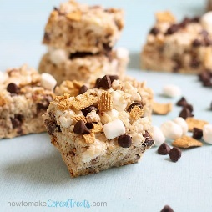 

# **Rice Krispies S’More**

**From the Kitchen of:** Mom

**Servings:** 9-10

**Prep Time: 1**0 min **Bake Time:** 30 Min. **Bake Temp:** 350

**Ingredients:**

* 3 Tbsp butter
* 10 oz package marshmallows
* 1 ½ cup marshmallows
* 6 cups Kellogg’s Rice Krispies
* 3 crumbled graham crackers
* ½ cup chocolate chips

1. In a large saucepan, melt 3 tablespoons of butter over low heat.
2. Add one 10 oz package of marshmallows and stir until completely melted.
3. Remove from heat.
4. Add 6 cups Kellogg’s Rice Krispies cereal along with 3 crumbled graham crackers. Stir until well-coated.
5. Stir in 1 cup marshmallows.
6. Using a buttered spatula evenly press the mixture into a greased 13x9 inch pan. Sprinkle with a ½ cup marshmallows and ½ cup chocolate chips. Broil for 2-3 minutes.
7. Let cool. Cut into 2 inch squares. Serve immediately.